Location:
Effective Date:
Revision Number: 1

[COMPANY]

This is a sample Coronavirus Action Plan. It is not meant to be exhaustive or construed as legal advice. Consult additional insurance and/or legal counsel for professional advice. Please modify this action plan to meet your company’s needs, taking all relevant federal, state and local compliance requirements into account.
The coronavirus (COVID-19) outbreak has impacted businesses across a variety of industries, forcing them to rethink their daily operations to ensure the safety of their employees and the general public. This is no different for construction firms, where multiple contractors and tradespeople on a job site may be working in the same space at any one time. In these instances, just one misstep can lead to the quick spread of COVID-19, jeopardizing the well-being of workers.
To help slow the spread of COVID-19 and safeguard our staff, [COMPANY] has created a standardized action plan for responding to COVID-19. This plan, which is based on Centers for Disease Control and Prevention (CDC) and Occupational Safety and Health Administration (OSHA) guidance, highlights responsibilities of managers and employees, job site safety measures and OSHA recordkeeping considerations. While there may be worksite-specific considerations to keep in mind, this action plan includes general strategies company officials and employees can use to address COVID-19 concerns and remain safe on the job.

Responsibilities
When it comes to ensuring a safe job site during the COVID-19 outbreak, both managers and employees have their role to play. The following is a breakdown of the responsibilities for [COMPANY] leadership and staff.
Managers and Supervisors
[COMPANY] leadership, including managers and supervisors, should familiarize themselves with the details of the action plan. Above all, leadership must be prepared to answer questions from employees and set a good example by adhering to the guidance prescribed in the plan. This involves practicing social distancing and good personal hygiene.
Employees
Employees play a critical role in [COMPANY]’s COVID-19 prevention efforts. To protect everyone on the worksite, [COMPANY] has a number of best practices employees should follow:
- Understand the signs and symptoms of COVID-19, and stay home if you are feeling sick—Any employee who is experiencing symptoms of COVID-19 (e.g., fever, cough, shortness of breath, sore throat, runny nose, body aches, chills or fatigue) should stay home. Individuals experiencing such symptoms should also be instructed to consult guidance from the CDC on seeking medical care.
- Practice good hygiene—Employees should clean their hands often, either with an alcohol-based hand sanitizer or soap and water. Hand sanitizers should contain at least 60%-95% alcohol, and employees should wash their hands with soap for at least 20 seconds. In addition, employees should avoid touching their face and cough into their arm.
- Practice social distancing—Social distancing is the practice of deliberately increasing the physical space between people to avoid spreading illness. In terms of COVID-19, social distancing best practices for employees can include:
  - Avoiding gatherings of 10 or more people
  - Keeping at least 6 feet of distance from other people
  - Hosting meetings virtually when possible
  - Working from home when possible
  - Refraining from shaking hands
  - Refraining from sharing tools and personal protective equipment (PPE)
Job Site Protective Measures
In order to keep staff safe and prevent the spread of COVID-19, [COMPANY] recommends the following job site protective measures:
General Safety Policies
- Employees, visitors and contractors who exhibit signs or symptoms of COVID-19 will be asked to leave the worksite.
- Where possible, meetings will be conducted virtually or via telephone. For in-person meetings, participants will be limited to groups of 10, and employees will be asked to remain 6 feet apart. Attendance will be tracked verbally in lieu of using a physical sign-in sheet.
- Employees will be asked to practice social distancing and should keep at least 6 feet of distance from co-workers, contractors and visitors.
- Employees should stagger lunches to limit the number of individuals congregating in break areas. [COMPANY] may divide crews to reduce the number of workers on the job site at any given time.
- [COMPANY] will provide access to handwashing stations and alcohol-based hand sanitizers.
- Employees should refrain from sharing tools and equipment. In instances where this is unavoidable, [COMPANY] will provide alcohol-based wipes and other cleaning materials that employees can use to clean tools and equipment.
- Employees will be asked to avoid using a common water cooler. For increased safety, [COMPANY] will provide employees with disposable plastic water bottles or instruct them to bring their own.

Workers Entering Occupied Buildings and Homes
- Employees should assess the unique hazards associated with occupied structures before entering them. Employees should ask occupants to keep at least 6 feet of distance from them.
- Employees should sanitize work areas before entering the building, throughout the day and then before leaving for the day. [COMPANY] will provide alcohol-based wipes for cleaning purposes.
Job Site Visitors
- [COMPANY] will limit visitors to the job site to necessary personnel only.
- [COMPANY] will screen visitors to the job site. Supervisors may ask targeted questions to visitors regarding their current health before they enter the job site. If they answer yes to the following questions, supervisors may ask them to go home and not return to the job site until further notice:
  - Have you been in contact with a person who has tested positive or is in the process of being tested for COVID-19?
  - Have you or anyone you’ve been in contact with traveled outside of the United States recently?
  - Has a medical professional told you to self-quarantine?
  - Are you having trouble breathing, or have you had flu-like symptoms within the past 48 hours (e.g., fever, cough, shortness of breath, sore throat, runny nose, body aches, chills or fatigue)?
- Deliveries will be permitted, but should be completed with social distancing best practices in mind.
Personal Protective Equipment and Work Practice Controls
- In addition to standard PPE, like hard hats and hearing protection, [COMPANY] will provide:
  - Gloves—Employees should wear gloves at all times while at the job site. The types of gloves employees use should be appropriate for the task at hand. If gloves aren’t typically required for a given task, any type of glove would be appropriate, including latex gloves.
  - Eye protection—Employees should wear eye protection at all times while on the job site.
- Employees should use N95 respirators if the task requires it. However, due to the current shortage of N95 respirators, employees are encouraged to reduce the need for masks by:
  - Keeping dust down through the use of engineering and workplace controls. This could involve using water-delivery or dust-collection systems.
  - Limiting their exposure to workplace dust.
  - Practicing good housekeeping to reduce dust on the job site.
Personnel Considerations
To ensure job site safety, [COMPANY] is committed to working with all personnel as well as third-party vendors and partners to prevent the spread of COVID-19. Specific precautions include:
- For general contractors [COMPANY] requires firms/individuals to:
  - Provide the materials and assistance necessary to increase job site hygiene.
  - Train their personnel on COVID-19 awareness and safety procedures.
  - Perform status checks and other meetings virtually to avoid large gatherings.
- For subcontractors, [COMPANY] requires firms/individuals to:
  - Develop a hygiene plan to supplement policies and procedures created for general contractors.
  - Refrain from in-person meetings when possible.
  - Train their personnel on COVID-19 awareness and safety procedures.
- For project superintendents and project managers, [COMPANY] requires individuals to:
  - Instruct employees to stay home if they are sick.
  - Ensure handwashing stations are well stocked.
- For safety professionals, [COMPANY] requires individuals to:
  - Communicate and execute on guidance from the CDC, OSHA, World Health Organization and other government sources.
  - Ensure employees are properly trained on COVID-19, particularly as it relates to preventing the spread of the disease.
  - Review existing policies on workplace hygiene.

Job Site Cleaning and Disinfecting
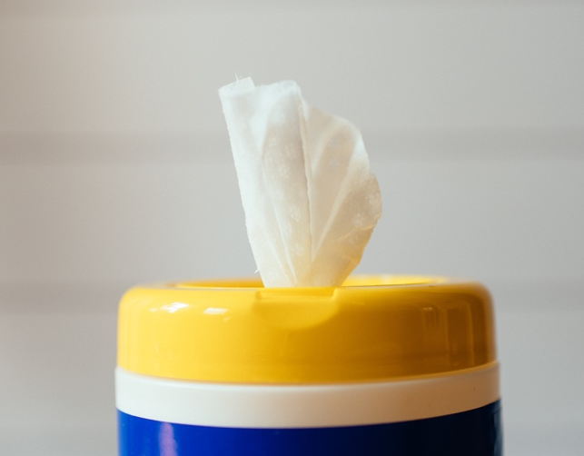
- The worksite, trailers and break areas must be cleaned at least once per day. This can involve sanitizing doorknobs, keyboards, tools, reusable supplies and equipment. Employees responsible for cleaning will be given the appropriate PPE. Cleaning should be completed using CDC-recommended products, including:
  - Environmental Protection Agency-registered household disinfectants
  - Alcohol solutions with at least 60% alcohol
  - Diluted household bleach solutions (if appropriate for the surface)

- Trash will be collected from the job site regularly. Those collecting trash will be instructed to wear nitrile, latex or vinyl gloves.
- Portable toilets will be sanitized at least twice per week.
- Frequently touched services will be disinfected often.
- Vehicles, equipment and tools will be cleaned at least once per day and before a change in operator or user occurs.
- Hand sanitizer dispensers will be refilled frequently.
- When an employee has tested positive for COVID-19, [COMPANY] will ensure areas in which the individual worked are cleaned thoroughly.

Job Site Exposure Situations
[COMPANY] has response plans in place for situations where employees exhibit symptoms of or tests positive for COVID-19.
Employee Exhibits Symptoms of COVID-19
In the event an employee shows symptoms of COVID-19, they will be asked to remain at home until they are symptom-free without the use of medications (e.g., fever reducers or cough suppressants) for 24 hours or four to five full days after symptoms improve. If possible, employees will be asked to obtain a doctor’s note before returning to work.
Employee Tests Positive for COVID-19
Employees who test positive for COVID-19 will be instructed to follow the advice of a qualified medical professional and self-quarantine. Specifically, employees who have tested positive should not return to work until they have been symptom-free for seven full days. Employees who have tested positive and been hospitalized should consult their medical care provider to determine when they can return to work. If possible, employees will be asked to obtain a doctor’s note before returning to work.
Employee Comes Into Contact With an Individual Who Has Tested Positive for COVID-19
Employees who have been in close contact with an individual who has tested positive for COVID-19 will be instructed to self-quarantine. Employees should self-quarantine for at least 14 days from the last day they had contact with the person who tested positive for COVID-19. If it was an employee who tested positive, [COMPANY] will conduct an investigation to determine who may have had close contact with said employee. Those individuals will also be instructed to self-quarantine.

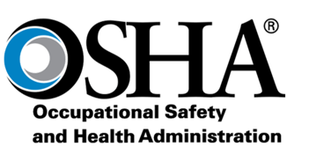
Osha Recordkeeping and Reporting
[COMPANY] will adhere to OSHA-mandated requirements as they relate to recording and reporting certain work-related injuries and illnesses.

Questions
If employees have any questions regarding the content of this action plan, they should be instructed to speak with their supervisor. Furthermore, while the strategies highlighted in this document can protect workers from COVID-19, it’s important to follow CDC guidance at all times. For more information, click here.

