* 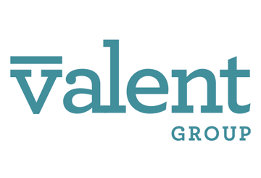The IRS has announced the affordability percentage that will apply under the ACA’s pay- or-play rules for plan years beginning in 2025.
* This percentage (9.02%) is an increase to the affordability threshold.
* ALEs will need to consider this affordability percentage in developing their health plan contribution strategies for the 2025 plan year.
* This increase may give employers more flexibility when setting employee contribution levels for 2025.

Pay-or-Play Affordability Percentage Will Increase for 2025

On Sept. 6, 2024, the IRS released [Revenue Procedure 2024-35](https://www.irs.gov/pub/irs-drop/rp-24-35.pdf) to index the contribution percentage in 2025 for determining the affordability of an employer’s plan under the Affordable Care Act (ACA). For plan years beginning in 2025, employer-sponsored coverage will be considered affordable under the ACA’s “pay-or-play” rules if the employee’s required contribution for self-only coverage does not exceed **9.02%** of their household income for the year.

Affordability Test

The ACA’s pay-or-play rules require applicable large employers (ALEs) to offer affordable, minimum-value health coverage to their full-time employees (and dependents) or risk paying a penalty. The affordability of health coverage is a key point in determining whether an ALE may be subject to a penalty. An ALE’s health coverage is considered affordable if the employee’s required contribution to the plan does not exceed 9.5% (as adjusted annually) of the employee’s household income for the taxable year. This percentage is adjusted annually based on health plan premium growth rates in relation to income growth rates.

In recent years, the affordability percentage has been adjusted to:

* 9.12% for plan years beginning in 2023;
* 8.39% for plan years beginning in 2024; and
* 9.02% for plan years beginning in 2025.

The affordability test applies only to the portion of the annual premiums for self-only coverage and does not include any additional cost for family coverage. Also, if an employer offers multiple health coverage options, the affordability test applies to the lowest-cost option that provides minimum value.

Because an employer generally will not know an employee’s household income, the IRS has provided three optional affordability safe harbors that ALEs may use to determine affordability based on information that is available to them: the Form W-2 safe harbor, the rate of pay safe harbor and the federal poverty level safe harbor.

Affordability Percentage for 2025

For 2025, the affordability percentage increases to 9.02%. This means that an ALE’s health coverage for the 2025 plan year will be considered affordable if a full-time employee’s required contribution for self-only coverage under the lowest-cost option does not exceed 9.02% of their income.

This is an increase from the affordability contribution percentage for 2024. As a result, some employers may have additional flexibility in setting their employee contributions for 2025 to meet the adjusted percentage.