Courtesy of Valent Group

Table of Contents
Introduction 3
Teen Driver Safety Tips 4
Preventing Distracted Driving 5
Don’t Text and Drive 6
Defensive Driving Tips 7
Stay Safe When Driving Alone 8
Driving in Extreme Weather 9
How to React After a Crash 10
Safe Driving Saves Money 11
The Good Student Discount 11
Shopping for a Safe Vehicle 13
Appendix 14
Parent/Teen Driving Agreement 15
4 Tips to Prevent Distracted Driving - Infographic 17
Safety Tips for Teen Drivers and Their Parents - Infographic 18
7 Tips for Adding Your Teen to Your Auto Insurance - Infographic 19
Tips to Save on Gasoline Costs - Infographic 20
What to Do If You're In an Animal Collision - Infographic 21
What to Do After a Car Accident - Infographic 22

Introduction
Driving is a significant responsibility. Not only does it require financial commitment, driving also comes with serious risks. It’s critical that newer drivers understand the potential risks and consequences associated with driving. By learning best safety practices and knowing the rules of the road, teens and young adults can drive with confidence and keep themselves safe.
This toolkit contains guidance intended to help parents have conversations with teen drivers about their safety behind the wheel. Be sure to check out the appendix for a teen driving agreement and a variety of infographics.
For even more safe driving resources, including videos and insurance-savings tips, parents should reach out to Valent Group.

Teen Driver Safety Tips
Research from the Centers for Disease Control and Prevention has found that drivers ages 16-19 are more likely to be involved in a motor vehicle crash than any other age group. Nevertheless, newly licensed teens can avoid accidents by upholding safe driving practices on the road.
Here are some general tips for staying safe behind the wheel.
- Always use your seat belt, even if you’re just going for a short drive down the block.
- Never drive under the influence of drugs or alcohol. Remember that prescription medications can impact your driving, too.
- Avoid driving at night if you don’t have much experience behind the wheel.
- Watch the forecast to avoid any inclement weather.
- Always try to stay at least four seconds behind the vehicle in front of you. This can help give you more reaction time in the event of an emergency.
- Never use your cellphone in your car.
- Keep your vehicle clean. A water bottle or soda can rolling around on the floorboard can roll under the brake pedal and prevent you from stopping. And if you reach for the water bottle while you are driving, you are very likely to wreck. Check and clean your car before you drive. Distractions can be more than a cell phone or food or passengers talking to you or loud music.
- Don’t drive with more than one other person in your car until you feel more comfortable behind the wheel—this will help you to stay focused on the road and the traffic around you.
- Check with your parent before offering a ride to a friend. Having a wreck is bad enough, but when you add passengers to the vehicle, this could impact your family financially.
- If you ever feel uncomfortable driving or feel as though the road conditions are too dangerous, pull over and park your vehicle as soon as it is safe to do so.

Preventing Distracted Driving
Distracted driving occurs whenever you engage in an activity behind the wheel that takes your attention away from the road. Such activities can include using your cellphone, eating, drinking, plugging information into your GPS or adjusting the radio.
Think distracted driving isn’t a serious concern? Think again. According to the National Safety Council, more than 3,000 people die each year as a result of distracted driving crashes.
Here are some things you can do to reduce potential distractions while you drive—keeping both yourself and others safe on the road.
- Never talk on your cellphone or text while driving. It’s dangerous and may be illegal.
- Never touch up your makeup or hair while driving.
- Limit your conversations with passengers and ask them to keep their voices down so you can concentrate on the road.
- Commit to a radio station or playlist before you begin driving and never adjust the music while driving.
- Don’t check your phone at stop lights. It’s good practice to simply ignore your phone until the car is completely turned off.
- Never allow animals to sit on your lap while driving.
- Don’t eat or drink while driving. This is very distracting and can be a choking hazard.
- Avoid reading maps or directions as you drive. Instead, pull into a parking lot to get your bearings and determine where you need to go next to reach your final destination.

Make the Road Your Sole Focus While Driving
Allowing yourself to become distracted while driving can lead to dangerous, and even fatal, consequences. Be a responsible motorist and make paying attention to the road your number one priority when you’re behind the wheel.

Don’t Text and Drive
According to research from the University of Utah, using a hand-held or hands-free mobile device slows a driver’s reactions as much as someone with a blood alcohol content of 0.08%, the legal limit in all U.S. states. What’s more, using mobile devices to call, text or email is a leading cause of distracted driving.
Text messaging is a useful way to communicate quickly, but safety should never be traded for convenience. Trying to write or read a text message while driving puts your full attention on your phone and not on the road, where it should be.
Distracted driving due to mobile devices isn’t just a problem with teenagers. Drivers of all ages are susceptible. Remember, just because a driver is more experienced does not mean that they can drive more safely while texting, calling or otherwise being distracted by a mobile device.
Every day, people are injured and killed due to a person texting while driving. Because of the increasing danger of distracted driving, many states now outlaw the use of cellphones in any capacity while driving—and your state may be one of them.
To avoid a ticket and a potentially dangerous accident, do not use your cellphone while driving. If you must absolutely make or answer a phone call or text, pull off the road in a safe area and then do so.

Think Twice Before Texting
Would you think it was okay for a doctor to be texting, emailing or carrying on an unrelated phone conversation while performing an operation? This may sound silly, but a driver and a doctor both have the safety of others in their hands. As a driver, you are responsible for your passenger’s safety while driving. Protect both yourself and others on the road by putting down your cellphone while driving.

Defensive Driving Tips
Being a defensive driver entails utilizing various road skills to defend yourself against potential accident hazards. Using proper defensive driving techniques will help keep both you and other drivers safe on the road. With this in mind, be sure to implement the following defensive driving guidance the next time you get behind the wheel.
- Eliminate distractions. The first step in being a defensive driver is to reduce distractions while you drive. As such, it’s important to make sure the road is your sole focus—avoid using your cellphone, adjusting the radio, programming your GPS, eating, drinking or applying makeup behind the wheel.
- Remain alert. In addition to eliminating distractions, it’s vital to be fully aware of your surroundings on the road. This practice will help you better detect upcoming hazards, allowing you to respond as quickly and safely as possible. Check your mirrors often, and try to scan road conditions approximately 20 to 30 seconds ahead of you. Specifically, keep an eye out for other drivers, nearby pedestrians and road obstructions (e.g., traffic cones or construction work).
- Follow the rules of the road. This includes wearing your seat belt, obeying speed limits, using your turn signals and avoiding driving with excess passengers in your vehicle. Also, make sure you approach intersections with caution—never run a red light or stop sign. Even if you have the right of way, look around to confirm it’s safe to cross the intersection before doing so.
- Avoid aggressive driving (and drivers). Aggressive habits—such as switching lanes frequently, braking or accelerating suddenly, and tailgating other drivers—can increase your likelihood of being involved in an accident. Try to be as predictable and forgiving as possible by always leaving at least a four-second distance between you and the vehicle in front of you, avoiding abrupt lane changes and keeping a steady pace. If another driver is displaying aggressive habits, try to distance yourself from them or pull over when it is safe to do so.
- Be extra careful in adverse conditions. In severe weather (e.g., heavy rain, snow and fog), road conditions can be significantly more dangerous. Take additional precautions by reducing your speed, increasing your following distance, braking earlier and using your headlights.

Don’t Forget to Take Care of Your Vehicle
Even the most defensive drivers could contribute to an accident on the road if operating an unsafe vehicle. Make sure you keep your vehicle in good shape by taking it for routine oil changes and fluid checks, ensuring the tires are properly inflated and performing other maintenance as needed.

Stay Safe When Driving Alone
It’s nice to have a family member or friend riding passenger in your vehicle while you drive—not only for companionship, but also for safety. In fact, recent research found that solo drivers are more likely to be targeted by criminals due to a lack of witnesses. As such, be sure to keep the following safety precautions in mind whenever you are driving alone.
- Have your keys in your hand when you are walking to your vehicle.
- If you are in an unsafe area, pre-dial 911 on your cell phone before walking to your vehicle.
- If you will be leaving after dark, park in an area that is well-lit and always lock your vehicle every time you get out.
- If you have been followed to your vehicle or suspect that someone is hiding in or near it, quickly move away and get help immediately. Always trust your instincts.
- If you believe you are being followed, do not drive home. Drive to the nearest safe, well-lit place and call 911.
- If safe to do so, look around and under your vehicle when you return to it. Check for flat tires, which may indicate that someone tampered with your vehicle.
- Look inside all the windows to make sure that no one is hiding in the back seat. If you notice anything suspicious, go find help immediately.
- Lock your vehicle doors once you are inside and keep the windows up whenever possible.
- If you are rear-ended, do not get out of your vehicle unless you are in a safe, public area. Notify your family and friends where you are going and when you are expected.

Utilize Your Vehicle’s Panic Button
If you are walking to your vehicle and notice someone who looks suspicious, hold down the panic button on your vehicle’s key fob or remote to signal trouble. This practice may deter the person because of the loud noise and attention that you are making. If you are inside of your vehicle and sense trouble, honk your horn repeatedly to get others’ attention.

Driving in Extreme Weather
Driving in adverse weather conditions can be downright nerve-wracking. It can also be very dangerous. Being aware of how to modify your driving during heavy rain, snow and fog can help you stay calm and safe during your journey. Consider the following tips when driving in extreme weather.
Rain and Thunderstorms
- Turn on your headlights, wipers and defroster to increase visibility.
- Drive in the tracks of the vehicle ahead of you and reduce your speed.
- If you hydroplane, hold the steering wheel straight and remove your foot from the gas.
Tornadoes
- If you are driving during a tornado, do not try to outrun it. Focus on finding a safe place to protect yourself while the tornado passes. Follow these best practices:
  - If the tornado forms in the distance, drive to a nearby public building (e.g., a bank or restaurant) and seek shelter.
  - If the tornado forms nearby, safely pull over to the side of the road, duck below your vehicle’s windows, keep your seat belt fastened and cover your head with your hands or a blanket.
  - If the tornado forms nearby and you have exited your vehicle, take cover in a low-lying ditch and cover your head with your hands or a blanket.
Snow, Sleet and Freezing Rain
- Clean ice and snow off your windows, hood and trunk before departing.
- Drive with extreme caution and at reduced speeds.
- Do not brake quickly as you may spin out of control.
Fog
- Slow down before you reach a patch of fog in front of you.
- Use only your low beams or fog lights and put on your defroster and wipers to increase visibility.
- If the fog is extremely thick, roll down all of your windows to hear other vehicles around you.

The Dangers of Tailgating in Rain or Snow
Apart from these top tips, allow extra room between your vehicle and the one in front of you when driving in snow or rain, seeing as you will need between three and 12 times the amount of stopping distance that you would normally need without any precipitation.

How to React After a Crash
In the event that you get into a car accident, it’s important to know how to react and make sure that the process goes as smoothly as possible. Whether it’s a fender bender or rear-end collision, consider the following guidance on how to respond after a crash.
- Get out of your vehicle and try to help anyone who is injured.
- Call the police or highway patrol immediately.
- Take photographs of your damaged vehicle and the scene. Note the date and time that the images were taken.
- Protect the accident scene by setting up flares, putting up cones or moving your vehicle off the road. Keep these items in your trunk at all times in the event of an accident.
- Once the police arrive, give them as much information as you can about what occurred. Do not admit fault; simply give the facts.
- Ask the investigating officer for a copy of the police report, as you may have to submit it with your insurance claim.
- Take as many notes and write down as many details as you can remember about the accident, and then call your parent and your auto insurance company to report your claim.
- Keep all records of correspondence that you have regarding your claim, including the date, name and title of the person that you talked to about the accident.
- Keep a record of any expenses that you incurred as a result of the accident. Depending on your policy, you may be entitled to reimbursement for those expenses.

Don’t Forget to Gather the Facts
This may sound easy, but many people forget to record the facts after an accident for one reason or another. It is important to get the names, address and phone numbers of everyone involved. Also, gather a description of the car(s) and license plate number(s), and make sure to get the insurance company and the vehicle identification number of everyone involved when you’re at the scene of the accident.

Safe Driving Saves Money
For better or worse, your automobile insurance premium is a direct result of your driving record. This amount is determined by the insurance company to cover the costs of insuring you and your family as drivers on the road.

How Safe Driving Lowers Your Premium
- Before giving you a premium price quote for your automobile coverage, insurance companies look at your driving record for the last three to five years.
- Your driving record reveals how risky you would be as an insured. Teen drivers don’t have a driving record, so they’re generally more expensive to insure initially.
- Those with lots of tickets and/or accidents are considered more of a potential liability because statistically, they will get into more accidents and have more tickets in the future.

How Safe Driving Protects Your Wallet
- If you have no accidents or tickets (especially moving violations) on your record recently, you may be eligible for a lower premium rate.
- You may also be eligible for a significant discount after several years of good driving.
- You may also be eligible for an accident forgiveness program if you’ve gone several years without an accident on your record.

What Safe Driving Can Do for Your Deductible
A good driving record can also reduce your deductible. For each year that you go without an accident or ticket, you may be eligible for deductible discounts, depending on the policy. This may be extremely beneficial for those who elect a higher deductible in exchange for smaller premiums.

The Good Student Discount
Teens and young adults often face hefty auto insurance premiums because, statistically, they are more likely to get into car accidents. However, most carriers offer a simple solution to combat this financial burden—offering a good student discount.

What Is the Good Student Discount?
The good student discount is an auto insurance discount provided by carriers that benefits students financially for their academic achievement. This discount offers reduced premium rates for current students that maintain a specific GPA or other measurable level of success in school.

Good Student Discount Qualifications
While specific qualifications vary between carriers and states, auto insurance companies might require students to meet the following or similar standards:
- Be under the age of 25
- Be currently enrolled full time in high school, college or university
- Maintain at least a 3.0 GPA
- Score in the top 20% on the PSAT, SAT or ACT
- Receive recognition on the dean’s list or honor roll

Receiving the Good Student Discount
In order to receive the good student discount, you will need to provide both proof of enrollment and proof of academic achievement. This proof can be provided to carriers in the form of a report card or transcript, standardized test score results, a letter from a school administrator, or a dean’s list or honor roll certificate.
In the case of a home-schooled student, you will need to provide a certification signed by a home-schooled certifying body, such as the State Department of Education.
Parents should speak with Valent Group to learn more about this potential discount and its requirements.

Shopping for a Safe Vehicle
Every new vehicle must meet certain federal safety standards, but that doesn’t mean that all vehicles are equally safe. Many automakers offer safety features beyond the required federal minimums. That’s why it’s important to carefully review the various safety features offered for a vehicle before finalizing your purchase.
Here are some key safety features to consider when buying a car.
- Crashworthiness—These features reduce the risk of death or serious injury when a crash occurs.
- Vehicle structural design—A good structural design has a strong occupant compartment, known as the safety cage, as well as front and rear ends designed to buckle and bend in a crash to absorb the force of the crash.
- Vehicle size and weight—The laws of physics dictate that larger and heavier cars are safer than lighter and smaller ones.
- Anti-lock brakes—Anti-lock brakes pump brakes automatically many times a second to prevent lockup and allow you to keep control of the car.
- Daytime running lights—These lights automatically turn on with your car. By increasing the contrast between a vehicle and its backgrounds and making the vehicles more visible to oncoming drivers, these lights can prevent daytime accidents.
- On-the-road experience—Other design characteristics can influence injury risk on the road. Some SUVs are prone to rolling over. "High performance" cars typically have higher-than-average death rates because drivers are tempted to use excessive speed.

Keep These Important Features in Mind
Seat belts, airbags and head restraints all work together with a vehicle’s structure to protect people in serious crashes. Lap and shoulder belts hold you in place, reducing the chance you’ll be ejected from the vehicle during a crash. If you aren’t belted, you’ll continue moving forward until something suddenly stops you (often a hard interior surface that will cause injuries). Consider each vehicle’s safety belt, airbag and head restraint features while you shop.

Appendix

This section includes various safe driving resources for a family to print and use. To print out any of these resources separately from the toolkit, please follow these instructions:
- Choose the “Print” option from the “File” menu.
- Under the “Settings” option, click on the arrow next to “Print All Pages” to access the drop-down menu. Select “Custom Print” and enter the page number range you would like to print, or enter the page number range you would like to print in the “Pages” box.

Parent/Teen Driving Agreement
Provided by: Valent Group

I, ____________________________, will drive carefully and cautiously and will be courteous to other drivers, bicyclists and pedestrians at all times.
I promise that I will obey all the rules of the road.
- Always wear a seat belt and make all my passengers buckle up
- Obey all traffic lights, stop signs, other street signs, and road markings
- Stay within the speed limit and drive safely
- Never use the car to race or to try to impress others
- Never give rides to hitchhikers
I promise that I will make sure I can stay focused on driving.
- Drive with both hands on the wheel
- Never eat, drink, or use a cell phone to talk or text while I drive
- Drive only when I am alert and in emotional control
- Call my parents for a ride home if I am impaired in any way that interferes with my ability to drive safely
- Never use headphones while I drive
I promise that I will respect laws about drugs and alcohol.
- Drive only when I am alcohol and drug free
- Never allow any alcohol or illegal drugs in the car
- Never accept a ride if the driver is not also alcohol and drug free
I promise that I will be a responsible driver.
- Drive only when I have permission to use the car and will not let anyone else drive the car unless I have permission.
- Drive someone else's car only if I have parental permission.
- Check the vehicle I am driving for loose items that could distract me such as water bottles and soda cans.
- Keep the vehicle clean.
- Pay for all traffic citations or parking tickets.
- Maintain good grades at school and complete my family responsibilities as listed here: ____________________________________________________
- Contribute to the costs of gasoline, maintenance and insurance as listed here: ____________________________________________________
Additional Promises:
_________________________________________________________________________
_________________________________________________________________________

I agree to the following restrictions, but understand that these restrictions will be modified by my parents as I get more driving experience and demonstrate that I am a responsible driver.
- For the next _____ months, I will not drive after ________ pm.
- For the next _____ months, I will not transport more than _______ teen passengers (unless I am supervised by a responsible adult).
- For the next _____ months, I won't adjust the stereo, air conditioning/heater or any electronic devices while the car is moving.
- For the next _____ months, I will not drive in bad weather.
- I understand that I am not permitted to drive to off-limit locations or on roads and highways as listed here: ________________________________________________________________
- Additional restrictions:
__________________________________________________________________________

Penalties for contract violations:
- Drove after drinking alcohol or using drugs | No driving for ___ months.
- Got ticket for speeding or moving violation | No driving for ___ months.
- Drove after night driving curfew | No driving for ___ weeks/months
- Drove too many passengers | No driving for ___ weeks/months
- Broke promise about seat belts (self and others) | No driving for ___ weeks/months
- Drove on a road or to an area that is off-limits | No driving for ___ weeks/months
I agree to follow all the rules and restrictions in this contract. I understand that my parents will impose penalties including removal of my driving privileges, if I violate the contract. I also understand that my parents will allow me greater driving privileges as I become more experienced and as I demonstrate that I am always a safe and responsible driver.
Signatures:
Driver: ______________________________________________ Date ________________
Parent promise: I also agree to drive safely and to be an excellent role model.
Parent (or guardian): ___________________________________ Date ________________
Parent (or guardian): ___________________________________ Date ________________

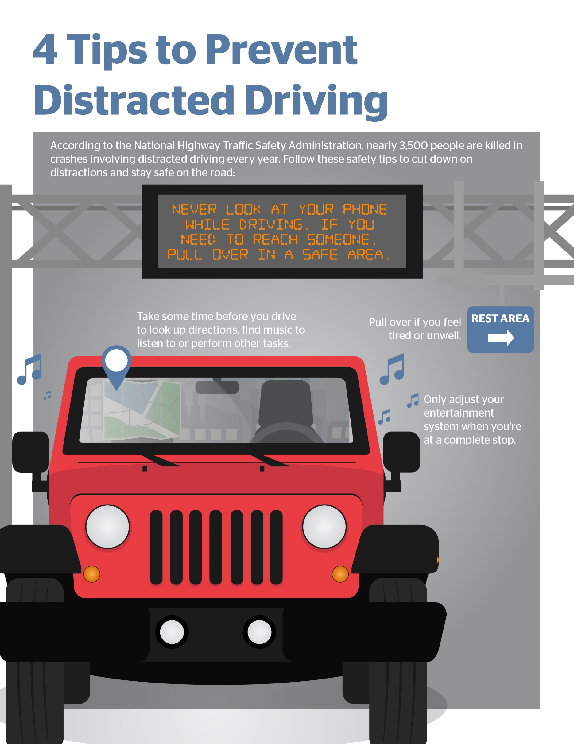
4 Tips to Prevent Distracted Driving - Infographic

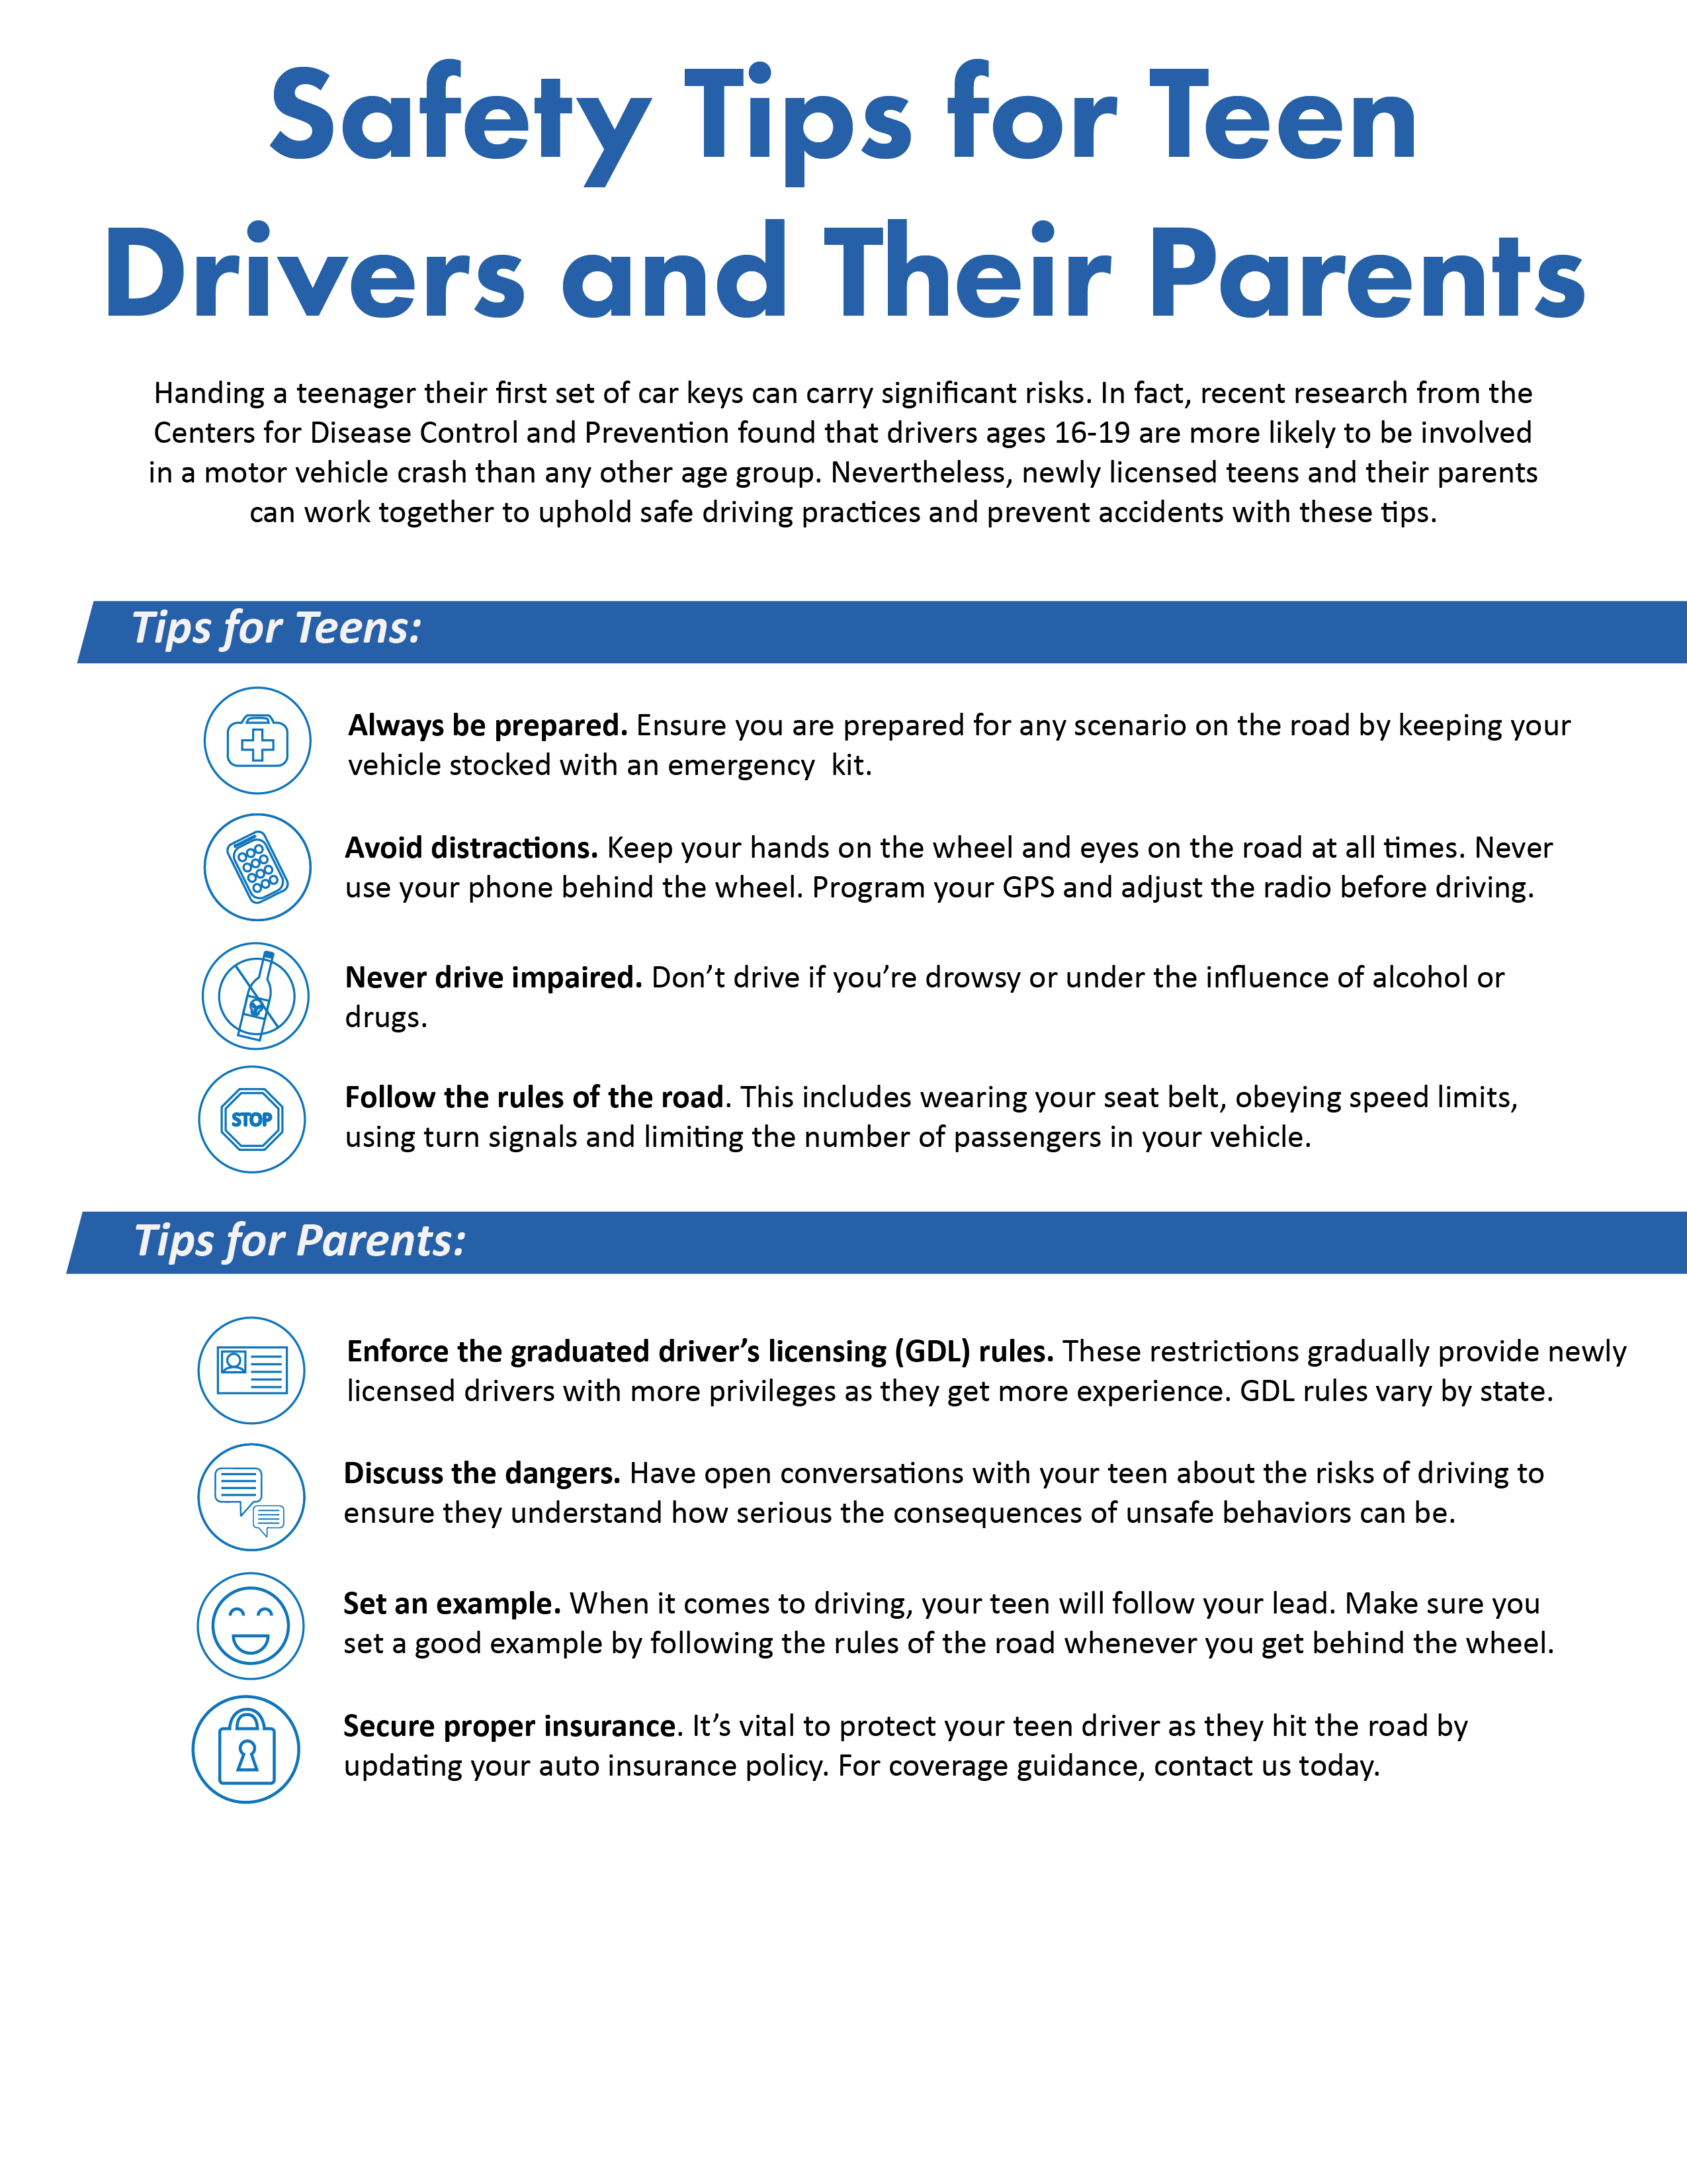
Safety Tips for Teen Drivers and Their Parents - Infographic

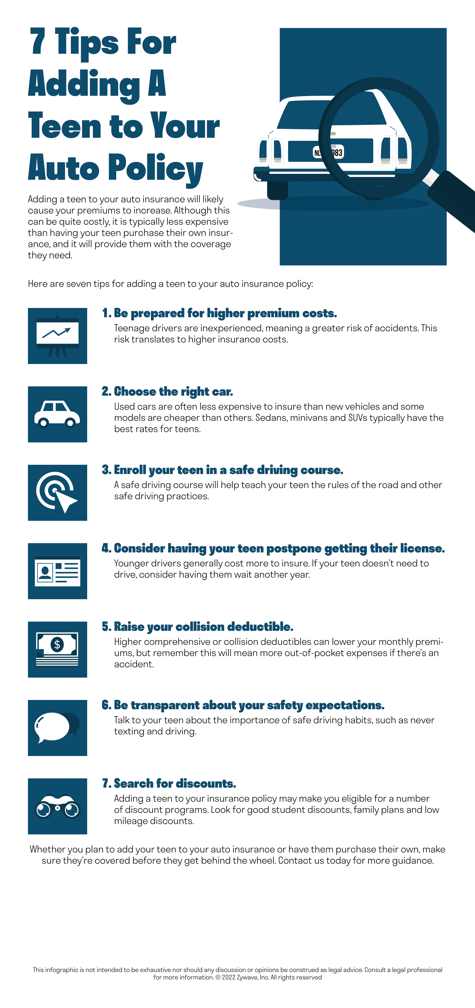
7 Tips for Adding Your Teen to Your Auto Insurance - Infographic

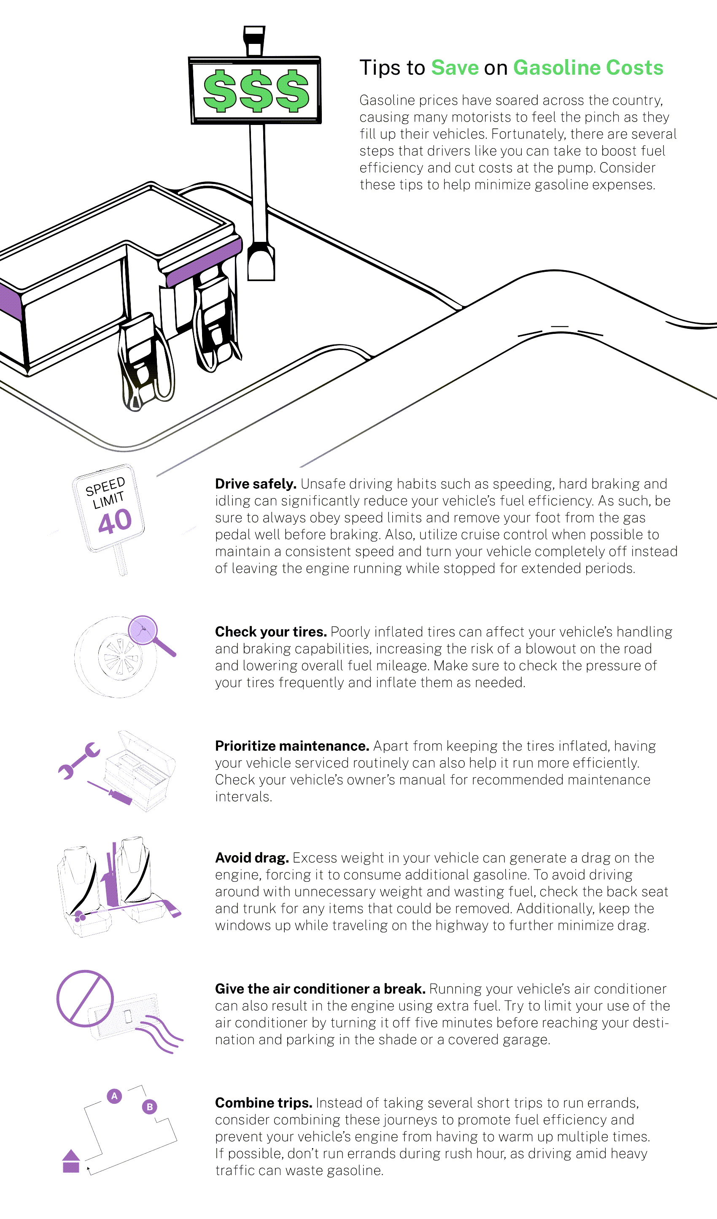

Tips to Save on Gasoline Costs - Infographic

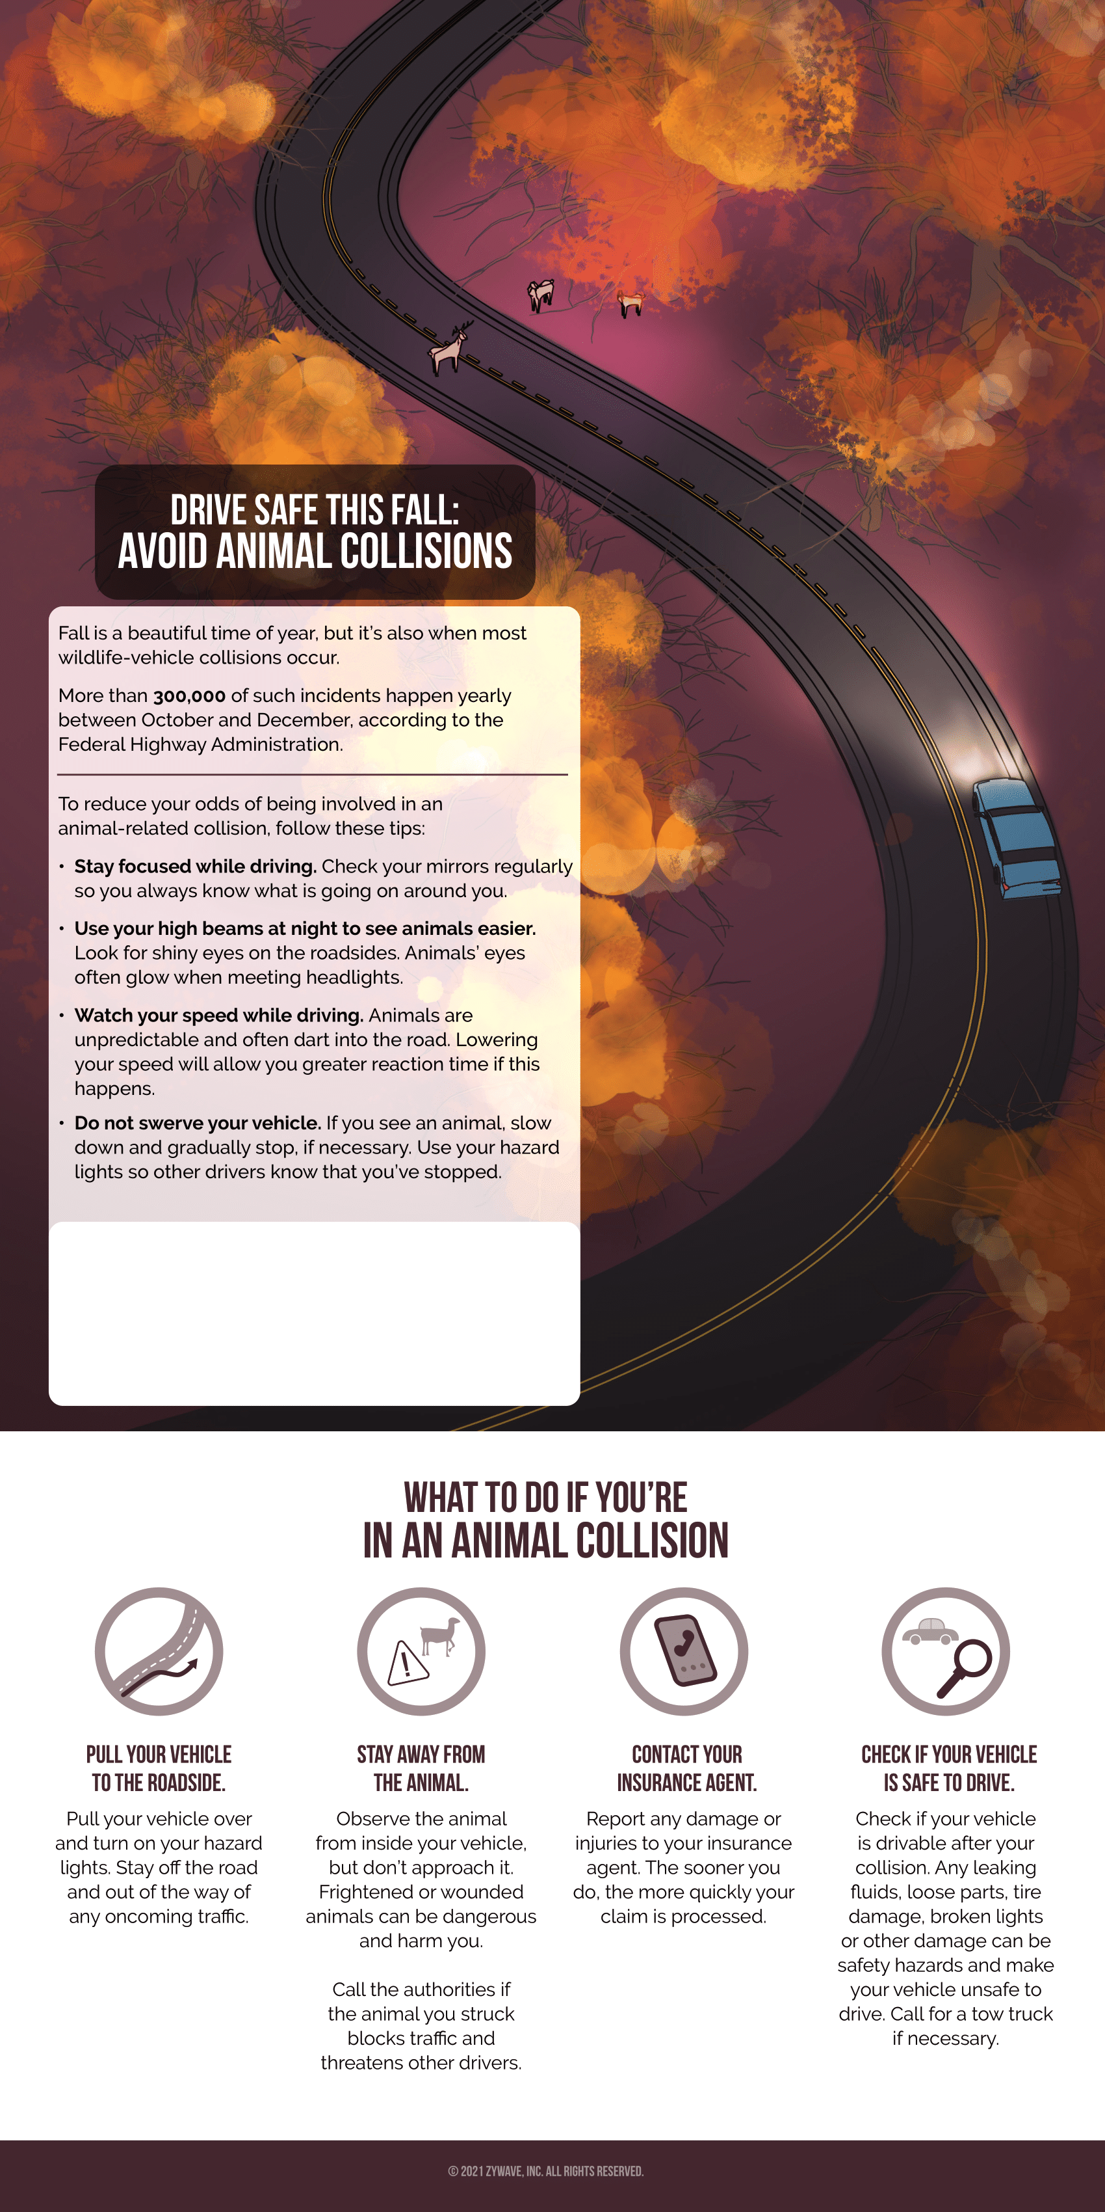
What to Do If You're In an Animal Collision - Infographic

Provided by:
Valent Group

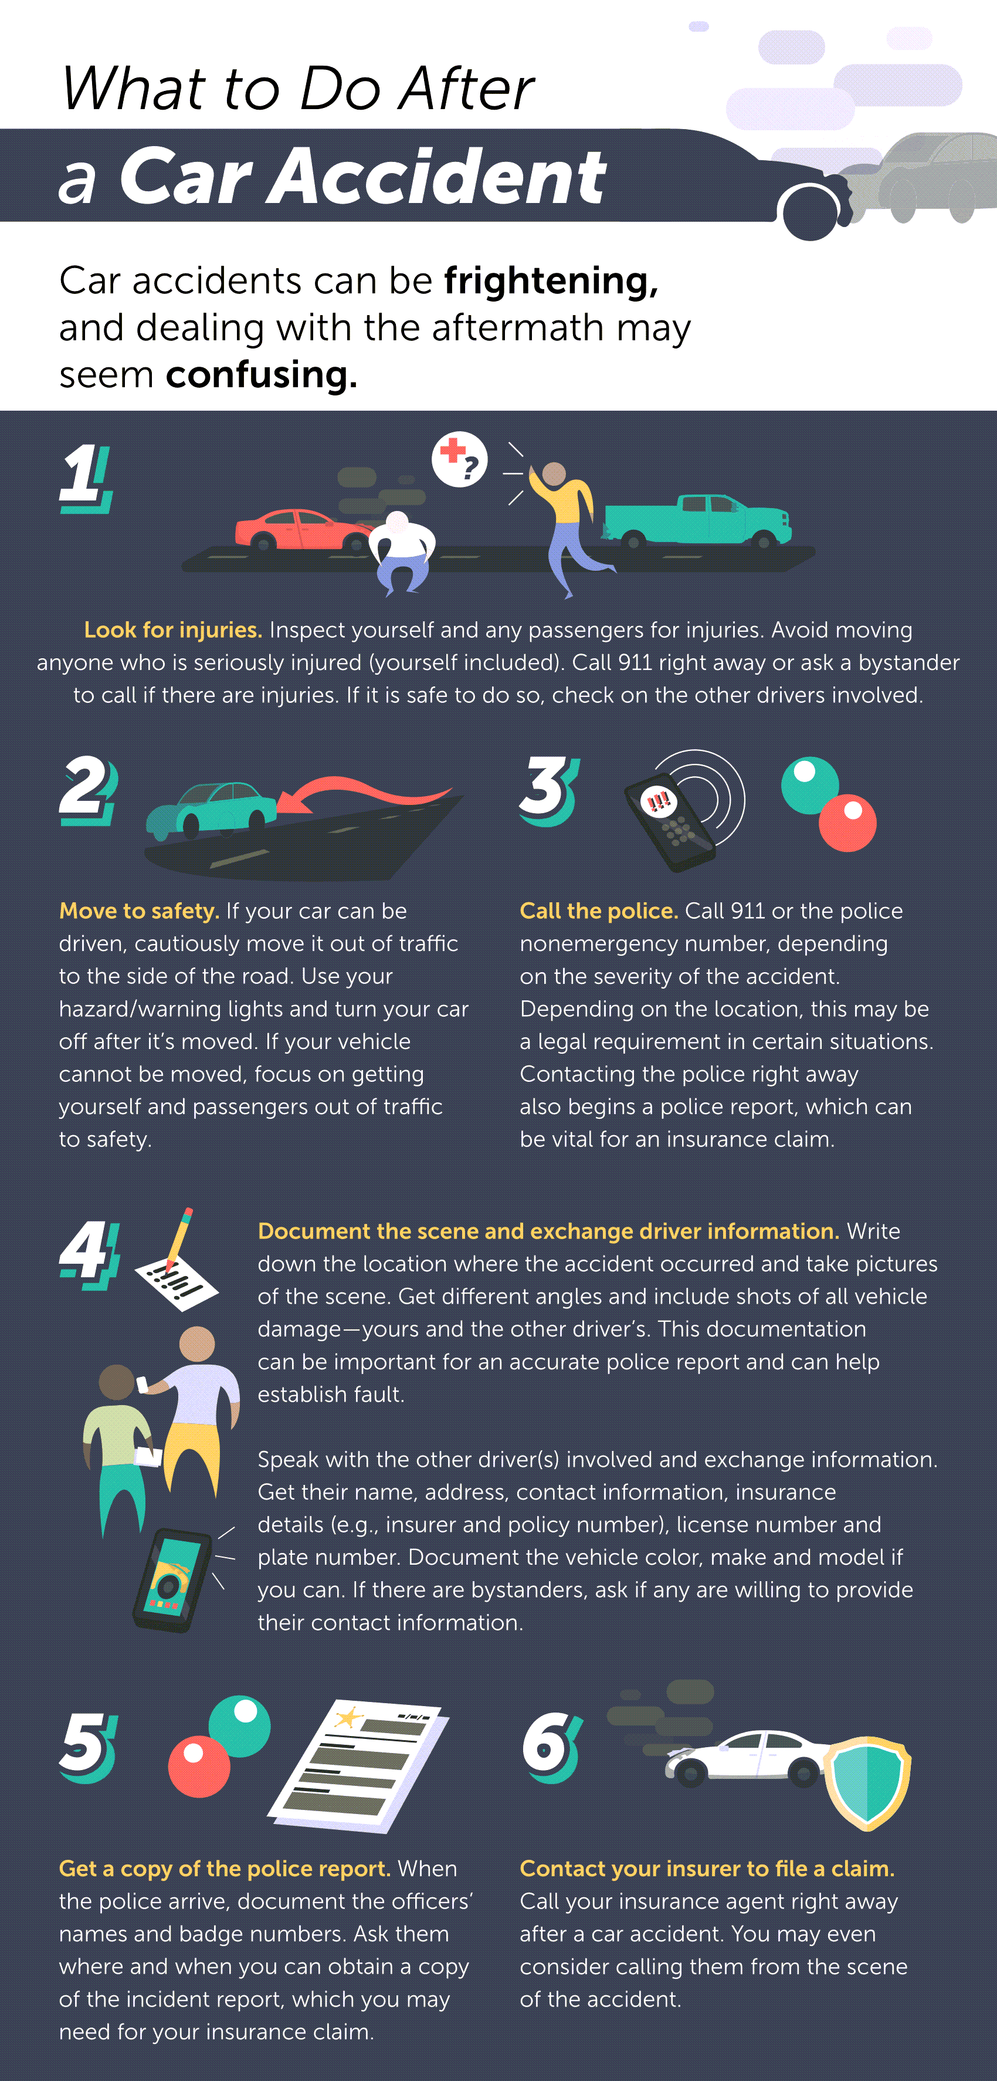
What to Do After a Car Accident - Infographic

